Technology Services/Technology Infrastructure Services Change Control Procedures
Originator: | Ruben Ybarra |  | Revision Date: | March 12, 2024
Revised: |  |  | Effective Date: | March 12, 2024
 |  |  | Original Date: | March 12, 2024
Purpose:
The purpose of this procedure is to ensure that all changes to the IT service are systematically managed to minimize business risk, preserve service availability, and maintain compliance with audit and regulatory requirements. The Change Management process applies to all modifications that could impact production systems, including hardware, software, network configurations, security settings, and application deployments. By adhering to a structured approach, the Technology Infrastructure Services (TIS) team can ensure that changes are properly evaluated, authorized, and implemented with minimal disruption.

Procedures
Contents
Scope and Definitions 3
Change Request Submission 3
Review and Approval Process 3
Scheduling and Communication 3
Implementation and Validation 4
Emergency Changes 4
Documentation and Audit Readiness 4
Metrics and Continuous Improvement 4
Normal CCR Workflow 4
Pre-Approved Change Control 6
Emergency CCR Workflow 7

Scope and Definitions
A change is defined as any addition, modification, or removal of approved systems or services that may affect IT operations. Changes are typically categorized as standard, normal, or emergency. Standard changes are low-risk, pre-approved, and follow a predefined implementation process. Normal changes require a formal review and approval from the Change Advisory Board (CAB), which evaluates the risk, impact, and feasibility of the change. Emergency changes are critical adjustments made to address immediate issues, such as outages or security vulnerabilities, and are subject to expedited review and post-implementation assessment by an Emergency CAB (eCAB)

Change Request Submission
The process begins with the submission of a Change Request (CR) through Remedy change management system. The requester must provide a detailed description of the change, including the business justification, potential impact, risk level, affected systems, test results, backout strategy, and define the implementation date. The Manager reviews each request to ensure it is complete and then classifies the change based on predefined criteria. Normal changes are routed to the CAB for evaluation, while emergency changes are escalated to eCAB. Approved changes are added to the Change Calendar and scheduled during established maintenance windows when possible.

Review and Approval Process
Normal changes are routed to the CAB for review. The CAB meets every Tuesday to assess pending changes. During the meeting, CAB members evaluate each request for risk, feasibility, resource coordination, and potential service impact. As part of the approval process, all changes must go through the Remedy workflow, which enforces a structured multi-level approval process.
This workflow ensures that each change is reviewed and authorized by the appropriate stakeholders—including technical teams, business owners, and Information Security before reaching CAB. The Remedy system automatically routes the request to designated approvers based on the change type and impacted systems, capturing electronic approvals to maintain an audit trail.
Only after all required approvals are received in Remedy is the change eligible for implementation Emergency changes are escalated to the eCAB, which includes key decision-makers who can authorize the change outside the normal review cycle. All emergency changes are reviewed retrospectively at the next CAB meeting for documentation and accountability.
.

Scheduling and Communication
Once approved, changes are added to the official Change Calendar and scheduled for implementation during established maintenance windows when feasible. Stakeholders are notified in advance of all changes, especially those with potential to impact operations. The Change Manager coordinates timing to avoid conflicts and ensures change sequencing is logical when multiple changes affect related systems

Implementation and Validation
The assigned implementer is responsible for executing the change in accordance with the approved plan. All actions taken must be documented, and any deviations from the plan must be communicated immediately. If issues arise, the implementer follows the predefined backout plan. After the change is applied, post-implementation validation is performed to ensure system functionality and confirm that no unintended impacts occurred.

Emergency Changes
Emergency changes are performed in response to incidents that threaten service continuity or security. While expedited, these changes still require a CR, risk assessment, and approval from designated eCAB members. The eCAB must review emergency changes for legitimacy and completeness no later than the following Tuesday CAB meeting. Emergency changes must include post-change documentation, including incident resolution details, test results, and any follow-up actions

Retroactive Changes
Retroactive changes refer to any modifications made to production systems without prior approval through the formal Change Management Process. These may occur in situations where immediate intervention was necessary to resolve an unexpected issue, and time did not permit proper submission and review. In such cases, a Change Request must be submitted as soon as reasonably possible following the change, clearly marked as “Retroactive.” This request must include a detailed explanation of the issue, the urgency, the steps taken, and the reason why the change bypassed the standard approval process. Retroactive changes are reviewed by the CAB during the next scheduled meeting (held every Tuesday) to assess risk, validate the resolution, determine if additional remediation is needed, and evaluate whether any policy or process gaps contributed to the exception. All retroactive changes are documented, tracked, and included in audit logs. Repeated retroactive changes without justification may be escalated to IT leadership for review and corrective action planning.

Documentation and Audit Readiness
All change activity, including approvals, test results, and implementation notes, is recorded in the change management system. This ensures traceability and supports internal and external audit requirements. The Change Manager maintains the official records and can produce audit logs upon request. Supporting documentation, such as screenshots, implementation guides, and test validation records, should be attached to the change request when applicable.

Metrics and Continuous Improvement
To ensure continuous improvement, the Change Manager tracks key performance indicators (KPIs) such as the percentage of successful changes, changes requiring rollback, unplanned outages linked to changes, and average time to close a change. These metrics are reviewed periodically and shared with IT leadership to identify opportunities for training, process improvements, or automation.

Normal CCR Workflow

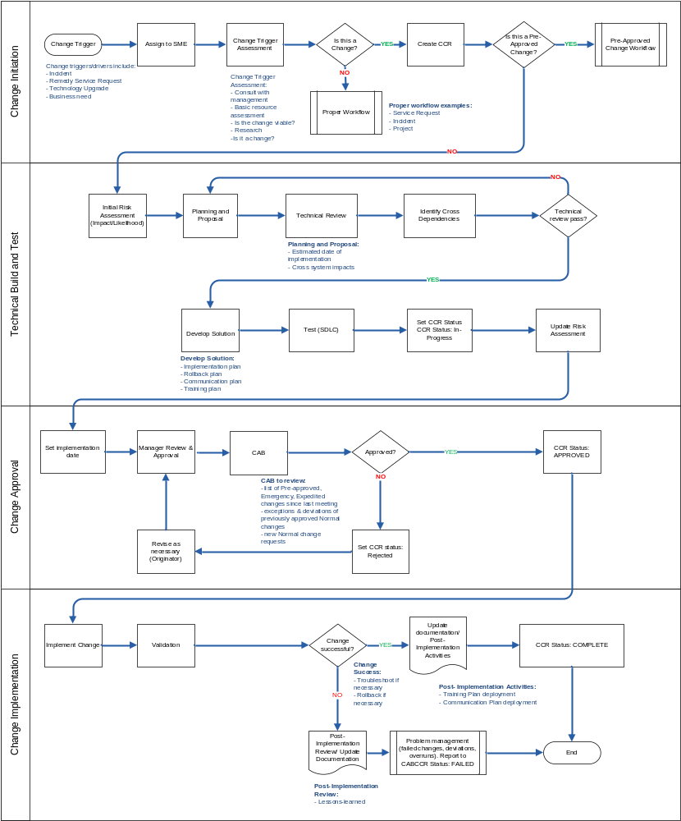

Emergency CCR Workflow

